**Kingsway Pre-Kindergarten School**

**Registration Information**

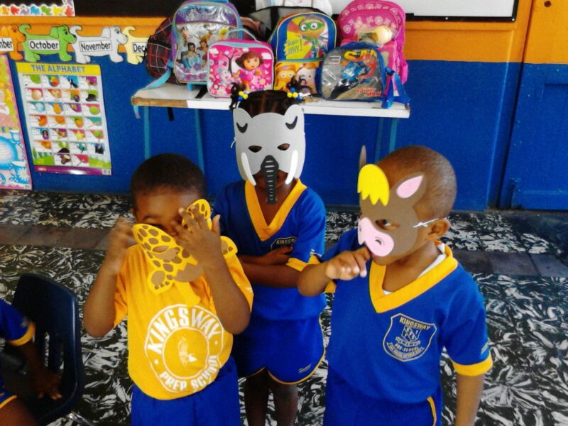

**10 – 12 Osbourne Road**

**Kingston 10**

**Telephone: (876) 968-5225, (876)968-9179**

**Fax: (876) 908-2050**

**E-mail:** [**kingswayhighandprep@gmail.com**](mailto:kingswayhighandprep@gmail.com)

**Website: www.kingsway.edu.jm**





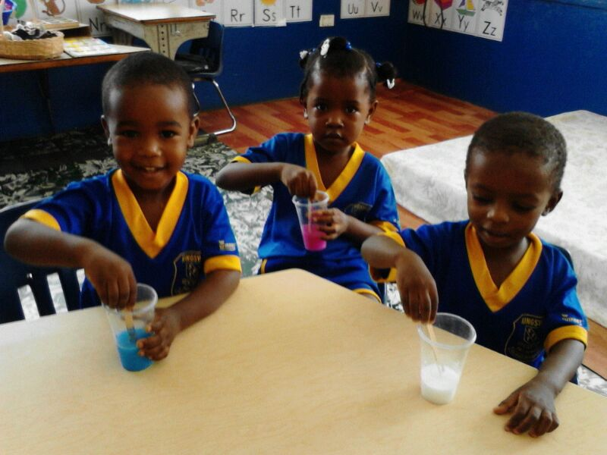

**Thank you for your interest in Kingsway Kindergarten and Preschool. It is our commitment to provide a quality Christ-centered education to our students. We believe that learning should be fun and look forward to having the opportunity to teach your child in a loving and caring environment.**

**This handbook has been prepared to provide you with general information about our programme. Please feel free to call the school’s office with any additional questions you may have. We would love to talk with you.**

**Introduction**

**Kingsway Kindergarten and Preparatory School, located at 10-12 Osbourne Road, Kingston 10, is owned and operated by the East Jamaica Conference of Seventh-day Adventists. The school is part of a global network of over 60,000 schools, colleges and universities operated by the Seventh-day Adventist denomination. Established on the belief that each child is educable and can develop to his or her potential, Kingsway will provide the opportunity for every child to develop spiritually, intellectually and physically through the process of a Christ-centered education.**

**It is a co-educational Seventh-day Adventist School and shares the same compound with the high department. The board chair is Dr. Eric Nathan, President of the East Jamaica Conference; the Director of Education, Dr. Donna Brown; and the Principal, Mrs. Alethia Williams.**

**Via Regis Optima Est**

**“The King’s Way is Best!”**

**Table of Contents  
General Information**

**Mission, Vision, Motto & Grad at Grad Statements……………5**

**Our Values……………………………………………………………………………………………6**

**Statement of Philosophy…………………………………………………………………7  
Administration…………………………………………………………………………………….8**

**Why Choose Kingsway………………………………………………………………………8**

**Enrolment Procedure…………………………………………………………………………9  
Financial Information…………………………………………………………………….10  
Educational Goals………………………………………………………………………….…11  
Curriculum, Goal and Objectives………………………………………..12-14  
Daily Schedule………………………………………………………………………………..15**

**General Policies**

**Classroom Standards………………………………………………………………15-16  
Discipline……………………………………………………………………………………….16**

**Birthdays……………………………………………………………………………………. 16  
Field Trips………………………………………………………………………………... 17  
Communication………………………………………………………………………….. 17  
Visitors……………………………………………………………………………………….. 17  
Emergency Plan……………………………………………………………………….… 18  
Guidelines for Sickness………………………………………………………….. 18**

**Staffing…………………………………………………………………………………………19**

**Covid-19 Visitors Guidelines……………………………………………………21**

**Mission Statement**

Established on the belief that each child is educable and can develop to his or her potential, Kingsway Kindergarten and Pre-School provides the opportunity for every child to develop spiritually, socially, intellectually and physically through the process of a Christ-centered education.

## VISION STATEMENT

Our school will function as a thriving community of learners empowered by God.

**Our Motto**

“Via Regis Optima Est”, "The Kings Way is Best!"

**Our Grad at Grad**

Each student at graduation will be:

1. A true disciple of Christ
2. Academically and vocationally sound
3. Committed to a holistic lifestyle
4. A world citizen committed to social justice
5. Relentlessly pursuing excellence in all endeavours

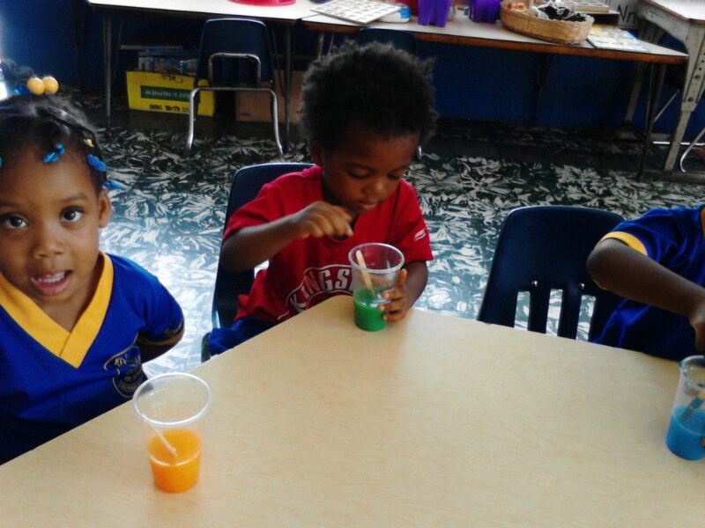

**OUR VALUES**

Teachers and students will subscribe to the values that characterize the school.

# Diligence

Exhibiting dedication to hard work, know how to manage time wisely.

### Commitment

Contributing to the holistic development of the students and the school’s programme

# Excellence

Always striving for the highest achievable level of success that will bring honour to God, self and school

# Fairness

Showing impartiality in all interactions

# Gentleness

Applying graciousness and sensitivity in all relationships

**Integrity**

Exemplifying the highest ethical standards, particularly in the areas of honesty and truthfulness

**Respect**

Showing due reverence to God, His sanctuary, civic leaders – every person, regardless of age, gender or socio-economic level.

**Self-discipline**

Exercising self-control and restraint in all interpersonal relationships

**Courtesy and Refinement**

Demonstrating refinement in deportment and speech representative of a character based on Christian principles.

**Statement of Philosophy**

The philosophy that undergirds the education provided at Kingsway Kindergarten and Pre-School is based on Seventh-day Adventist beliefs and practices, which hold that God, who is infinitely loving, wise and powerful, relates to human beings on a personal level. Adventist education, therefore, imparts more than academic knowledge. Our school seeks to create a conducive atmosphere for the physical, intellectual, spiritual and social development of its students. Curricular and co-curricular activities are designed to place a wholistic stamp on students’ learning, thus preparing them to be successful and exemplary youth who will serve the organizational needs of the Seventh-day Adventist Church in particular and the society in general.

The ultimate purpose of education is the restoration of God’s image in the students. It is our belief that the provision of a suitable environment for the practices taught by the Seventh-day Adventist Church will lead to the development of godly character. The education provided in this school, therefore, seeks to promote a life of faith in God and respect for the dignity of all human beings.

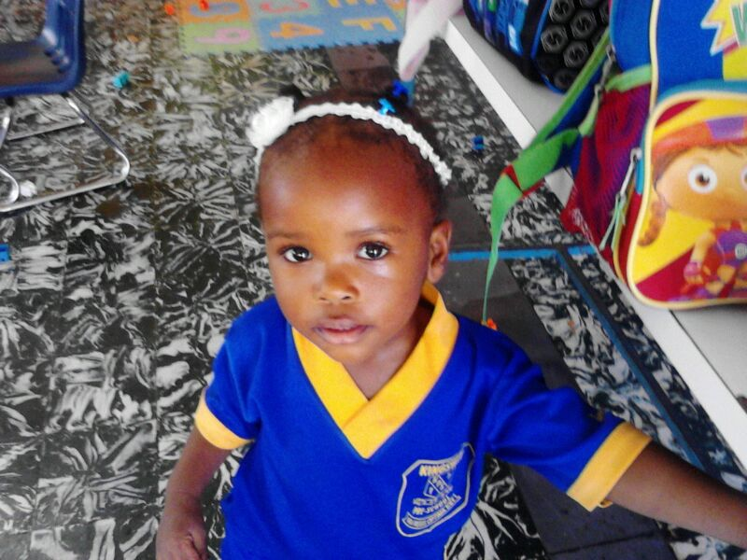The expected product of education at Kingsway Kindergarten and Pre-School is students who, having acquired knowledge, will be adequately equipped to move through the educational system and to function in their social circle. To this end, the education provided seeks to nurture students who are thinkers rather than mere reflectors of other men’s thoughts, promote loving service rather than selfish ambition, ensure maximum development of each individual’s potential, and lead students to embrace all that is true, good and beautiful.

**Administration**

The administrative policies of Kingsway Kindergarten and Pre-School are made by the Board of Directors in conjunction with the East Jamaica Conference of Seventh-day Adventist, who owns and operates the school.

Parents are encouraged to bring any concerns they may have to the attention of the Principal or Vice Principal of the school who will then take them to the Board of Directors if necessary. You may also contact the Home and School Association Body if you have an item you would like placed on the monthly meeting agenda.

All applicants for teaching positions are reviewed by the Administrators and Board of Directors.

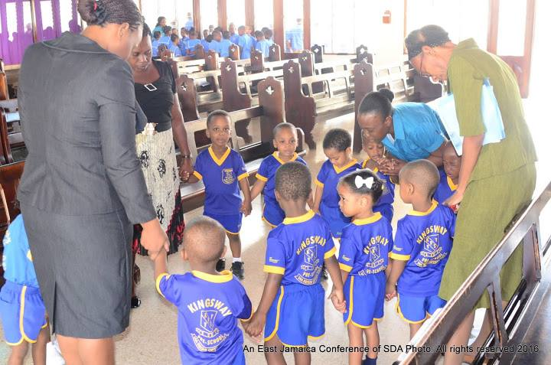

W**hy You Should Choose Kingsway Kindergarten & Preparatory School**

* High Christian Moral Standards
* Caring, Efficient Teachers
* Good Discipline
* Small Classes
* Excellent results in Grade Six
* Achievement Test (GSAT)
* A pleasant, quiet work atmosphere
* Special emphasis on reading
* Schools’ participation in National
* Educational Programmes

# Enrolment Procedure

Enrolment for the Academic Year is done from April – June for September Registration and in November for January Registration. However, students may be enrolled at any time during the school year as long as spaces are available.   Any requests for special accommodations or changes to the enrollment procedures listed below must be made in writing to the school’s office and approved by the Principal/Vice Principal.  All placements are made on a first come, first served basis.

1. **Age for Enrolment**

Students must be two years old by September 1 to enroll for the Pre-School and three years old for Kindergarten.

1. **School Tour**  
   Set up a tour with the school office. You will receive basic school information at that time and be able to see the school facilities and ask questions.
2. **Submit Application Form and Enrollment Fees**  
   A new student application fee of $2,000 is required to secure your student’s space in a classroom.
3. **Return Student Enrollment Forms**  
   Upon reaching this step all Registration Forms must be returned to the school office with the required documents at least 1 month prior to start date.
4. **Assessment/Observation & Consultation/Family Interview**

An Assessment/Observation is done with the student by members of our Academic Committee. Following the Assessment/Observation, consultation/interview is done with the parents/guardians.

1. **Committee Approval for Admission**

All documents are sent to the Admission/Academic Committee for final approval

1. **Classroom Visit (optional but highly encouraged)**  
   Make arrangements through the school office for your child to spend at least 1 day in the classroom prior to their first full day of enrollment.  This allows students to make an easier transition into their classrooms, an opportunity for parents to meet the student’s teachers, and for both the school and family to gather feedback on student readiness for the classroom.

**Financial Information**

# Fee Structure For Academic Year 2020/2021

|  |  |  |  |  |
| --- | --- | --- | --- | --- |
| **Description** | **Term 1**  **September** | **Term 2**  **January** | **Term 3**  **April** | **Annually** |
| Tuition | 44,000.00 | 44,000.00 | 44,000.00 | 132,000.00 |
| Miscellaneous Fee | 3,000.00 | 3,000.00 | 3,000.00 | 9,000.00 |
| **Total** | **$47,000.00** | **$47,000.00** | **$47,000.00** | **$141,000.00** |

Please make every effort to meet all dates set for registration/voucher day. Late registration will attract a fee of **$3,000.00**

Please note the following:-

* Parents who pay school fees in full for the year by the end of August will receive a 5% discount.
* No student with an outstanding balance will be registered for a new term until the balance is cleared.
* All students must have a valid permit to attend classes.
* Students with outstanding balances will not be allowed to take examinations.

**Refund Policy**

1. **Voluntary Withdrawal:**

Beginning of the term to two (2) weeks - 90%

Two weeks to four (4) weeks - 60%

Four weeks to six (6) weeks - 40%

After six (6) weeks - No Refund

There is no refund on general fees

**Educational Goals**

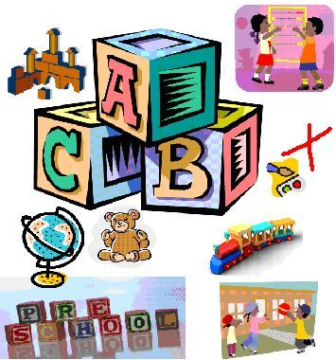

**Based on our philosophy of education, each individual child will be encouraged to learn and grow….**

**Spiritually  
with Jesus Christ**

**Cognitively  
by gaining greater knowledge and understanding**

**Socially  
through positive interaction with teachers and peers**

**Emotionally  
by creating positive self-worth**

**Physically  
by developing strong, healthy bodies**

**Creatively  
 through art, music and movement**

**Curriculum**

**The Kindergarten Division utilizes the Jamaica Early Childhood Curriculum approved by the Early Childhood Commission ( Birth to Three is Key and Four to Five –Getting Ready for Life). The curriculum addresses the holistic development of each child through the four main domains; namely language, physical (fine, gross), cognitive and reasoning, socio-emotional and creative. Our Seventh-day Adventist Believes are also integrated into the curriculum, this is called” Integration of Faith and Learning.’**

**Our children are engaged and exposed to a variety of extracurricular activities such as Spanish and sign language. We assess our children at least once per year using developmentally appropriate milestone and ensuring that all areas of development are assessed. Children who are identified as needing specialized interventions are referred to the appropriate agencies/specialists for the necessary interventions. It is our goal to prepare your child for successful Kindergarten and Pre-School entry.**

**GOALS & OBJECTIVES OF THE PROGRAMME:**

**Goal:**

**Physical** (fine motor, gross motor) - The children are provided with a variety of supervised activities which will enhance their physical growth and development:

* Scribbling, painting, tearing, beading, zipping, tracing, painting, feeling (Fine motor)
* Running, jumping, throwing, catching, skipping, climbing, walking etc (Gross motor)

**Objectives:**

***Fine Motor:***

1. Plan and execute specific fine motor activities daily for all age groups.
2. Develop and implement an anthology of fine motor activities (finger plays, games-
3. Create games and other fine motor materials (table top activities).

***Gross Motor*:**

1. Plan and execute specific gross motor activities daily for all age groups.

2. Establish a safe outdoor play area with age appropriate play equipment.

3. Develop and implement an anthology of gross motor activities (ring games).

**Goal:**

*Cognitive and reasoning* – Provide cognitive and reasoning development activities which will enable our children to think, solve problems, make decisions and make sense of the world around them.

**Objectives**:

1. Plan and execute specific cognitive and reasoning activities daily for all age groups.

2. Provide adequate cognitive and reasoning materials.

**Goal:**

*Language* – Provide activities that will develop and enhance language skills effectively.

**Objectives:**

1. Accept children’s use of the Jamaica Dialect while encouraging and modeling the use of the Jamaican Standard English.
2. Provide developmentally appropriate materials and activities which will foster early reading and writing skills.
3. Provide and utilize additional materials with sounds (CD’s, tapes, Television, DVDs) to encourage language development

**Goal:**

***Socio-emotional*** – Provide opportunities that teach children respect for self and others, culture, religion and community.

**Objectives:**

1. Plan and execute specific socio-emotional activities daily for all age groups.
2. Provide an environment in which practitioners model behaviours of respect, fairness, honesty and acceptance of differences.
3. Provide opportunities that teach children self-help skills (toiletry, hand washing/ sanitizing)

**Goal:**

***Creative***– Nurture the development of creativity by providing the children with a variety of activities.

**Objectives:**

1. Plan and execute specific creative activities daily for all age groups.

2. Establish all five learning areas (language and reading, manipulative and cognitive, art and sensory, science and nature, dramatic play).

3. Engage the children in music and movement.

**Each student is treated as an individual and encouraged to grow at his/her own rate. Our curriculum is based on our educational goals and includes:**

**Activity Centers:**

* Play area for role playing
* Building blocks for dexterity and pre-math concepts
* Manipulative games and puzzles for dexterity, cognitive growth, and developing fine motor skills
* Reading Corner for early literacy and language skills
* Science for discovering God’s World
* Creative arts and crafts, sensory stimulation

**Circle Time:**

* Relational skills are developed
* Calendar and weather
* Letters, numbers, shapes, and color reinforcement
* Music, movement, singing, and instruments

**Bible Time:**

* Worship
* Bible stories from the Old and New Testaments emphasizing Christian life application
* Bible verses
* Sharing and prayer time

**Recess:**

* Facility for physical activity, large motor skill and social development
* Outdoor play area

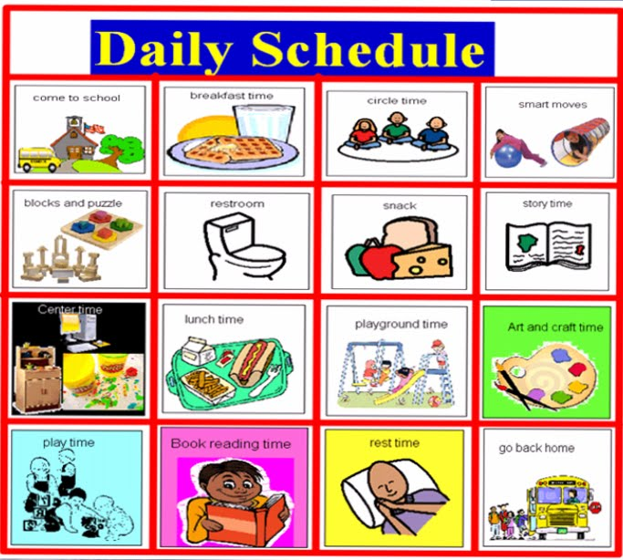**Daily Schedule**

Kingsway Kindergarten and Pre-School operates Monday – Thursday - 7:00 a.m. to 2:00 p.m. for the pre-school and 8:00 a.m. – 1:30 p.m. for Kindergarten, and on a Friday – 7:30 a.m. – 1:00 p.m. Teachers are responsible for the children up to one (1) hour after dismissal, after which they are placed in the Afternoon Care Programme, which runs from 2:00 p.m. – 6:00 p.m. Our classes begin in September and end in June.

It is requested that students arrive no sooner than 10 minutes before school begins to allow teachers prayer and preparation time. Please pick up children promptly at the close of school or arrange for them to be placed in the Afternoon Care Programme.

It is important that you inform the teacher (in writing whenever possible) of any arrangements you have made for your child to be picked up by someone other than the parents.

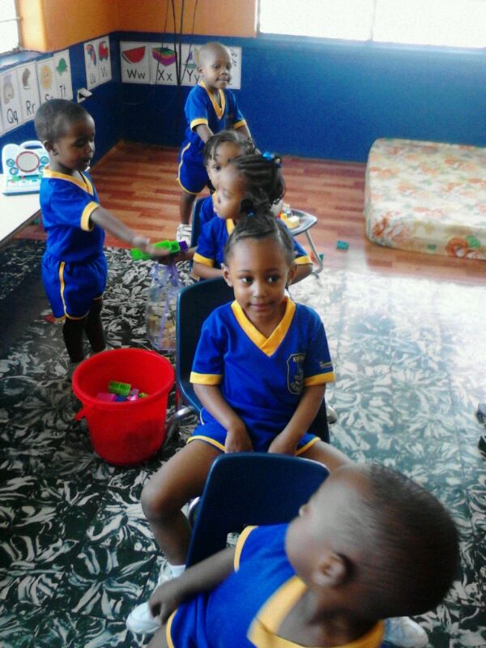**Classroom Standards**

We want your child to feel as comfortable as possible on his/her first day of school. We suggest you introduce your child gradually by attending orientation day. This is an opportunity for the students to attend school with their parents, meet the staff and fellow students, and see the classroom and things they will be doing.

All children should wear comfortable clothes and shoes so they will be free to enter into play. Girls in Kindergarten are required to wear shorts underneath their uniform as to remain modest when on the playground or during circle time.

Students are required to bring a backpack/tote bag and folder to preschool daily for transporting their papers, art, snacks/lunches and any other miscellaneous items. Please also include a change of clothes.

We are prepared to serve only healthy children. We ask that you send your child to school only if he/she is not ill. (Please take a look at the guidelines for sickness)

All children should come to school with nutritional lunches, snacks and juices or make arrangement with the class teacher for lunch from the school’s canteen. No fizzy drinks or sweets will be accepted. Please make sure to bring to the teacher’s attention any allergies your child may have as special treats may be served for birthdays and holidays.

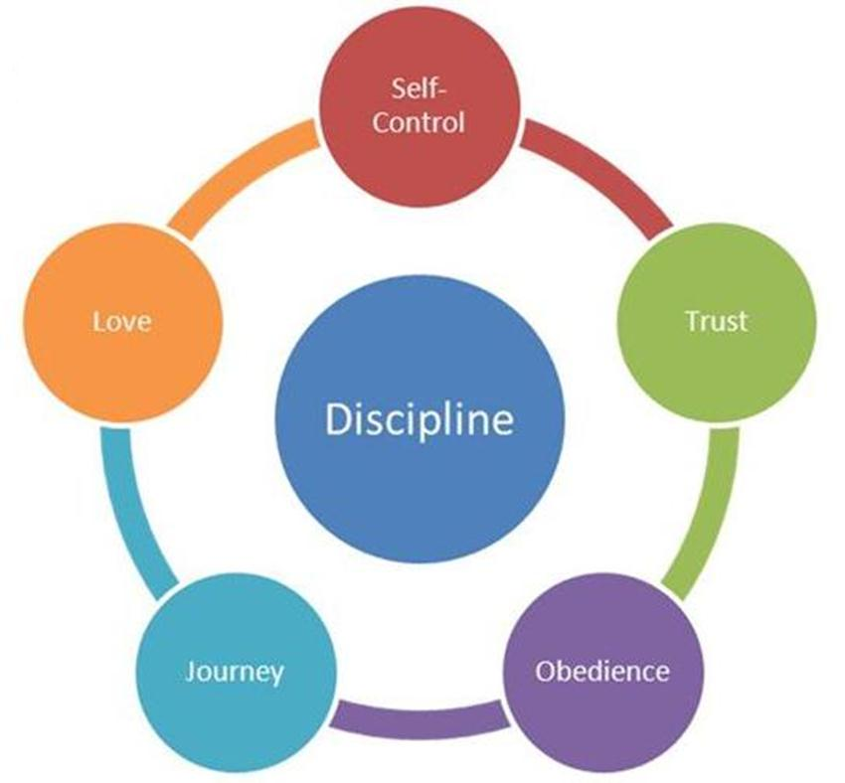**Discipline**We make every effort to have a discipline policy that practices positive reinforcement by praising good behavior and teaching self-control. If a child’s behaviour indicates he may harm his/herself or others or seems to be taking away from the educational opportunity of others, he/she will be temporarily removed from the immediate group. This will only be for a short time to help the child settle down and reflect on his/her behavior with the teacher’s guidance so they can rejoin the group.

We believe discipline should be an opportunity to train the child in love. If a child has a continuing problem, the parent will be contacted for a conference so we can work on the problem together and maintain consistency.

**Birthdays**

Your child’s birthday may be celebrated at school by scheduling a date with the teacher. Parents may provide a special treat to share during our snack time. Special paper products or favors for the class may be sent in but are not necessary.

****If you are having a birthday party for your child and wish to send invitations to school, you may do so if the whole class or all boys/girls are invited. Otherwise, we would prefer you give them to individual parents to avoid hurt feelings.

**Field Trips**

Kingsway Kindergarten and Preschool will provide field trip opportunities at different times throughout the year. They will be communicated to the parents through the calendar of events and notices. Parents are welcome and encouraged to attend with the students when this is necessary.

**Communication**

While we keep scheduled Parent/Teacher Conferences throughout the year, open communication is incredibly important. We will contact you as the parent or guardian if there are any concerns that need to be addressed with your child. We encourage you to contact us at any time if you would like to discuss your child.

**Visitors**

Parent visits are welcomed. However, please schedule them whenever possible to avoid too many changes to our daily schedule. If you have any outside observers (i.e. speech therapist) that need to come, please have those visits scheduled through the Vice Principal.

**Emergency Plan**

Our emergency plan is as follows:

1. Isolate ill or injured child with a teacher.
2. Facilitate First Aid if necessary.
3. Contact parent or guardian immediately if serious.
4. Arrange to take child to the hospital if necessary
5. Record all illness and injuries immediately.

We have a full-time nurse on staff at Kingsway. Also, some teachers are CPR and First Aid certified. We also practice with the students our emergency exits during fire drills.

**Guidelines for Sickness**

It is in everyone’s best interest if children stay home if they are not feeling well and would have trouble keeping up with the group. We rely on parent’s judgment on whether or not to send their child to school.

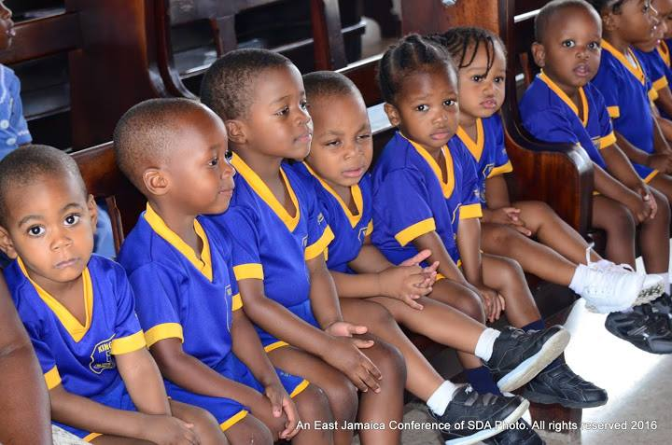 Most infections are spread before a child appears sick or begins exhibiting symptoms; however, please do not send your child to school if he/she exhibits the following symptoms: a fever or having had one in the last 24 hrs.; thick, colored nasal secretions; vomiting or acute diarrhea; a red, sore throat; an eye infection that hasn’t been treated; infected, untreated skin rashes or lesions; rapid or labored breathing; severe pain or discomfort; or a communicable disease (such as pertussis) that is still in the contagious stage.

**Staffing**

**Instructional Staff**

Pre-School - 1 Classroom Teacher

1 Caregiver/Assistant Teacher



Kindergarten 1 - 1 Classroom Teacher

1 Assistant Teacher

Kindergarten 2 - 1 Classroom Teacher

1 Assistant Teacher

Kindergarten 3 - 1 Classroom Teacher

1 Assistant Teacher

**Administrative/Clerical Staff**

1 Principal

1 Vice Principal

1 Bursar

1 Assistant Bursar

1 Administrative Assistant

2 Clerical Assistants

**Kitchen Staff**

1 Chef

1 Assistant Chef

2 Servers

1 Supervisor

**Janitorial Staff**



1 Male Janitor

1 Female Janitor

**COVID-19 VISITORS’ GUIDELLINES**

At Kingsway Kindergarten and Preparatory School, we are committed to keeping our community safe and healthy. Our student’s health and safety is always our number one concern. Because of the public health crisis we are facing, we have implemented some guidelines for any visitors coming into our facility.

Reschedule your visit if you have any flu like symptoms or fever within the previous 3 days

* Must wear a mask when entering the facility
* Only 1 adult visitor per visit, no children please
* Wash hands after entering the facility
* Maintain social distancing - 6 feet from others while on the premises
* May not enter any of the classrooms where students are present
* Refrain from touching any materials or activities that are actively used by students or staff

Kingsway Kindergarten and Preparatory School Staff and Families would like to thank you in advance for your diligence and support in keeping our community safe.

Thank you,



**APPENDICES**

Application Form

Field Trip Form

Calendar of Events

Emergency Contact Form